DRAFT FINAL PROPOSED PLAN
FOR
MUNITIONS RESPONSE SITE (MRS) 03 AND 05
CONWAY BOMBING AND GUNNERY RANGE
FORMERLY USED DEFENSE SITE (FUDS)
HORRY COUNTY, SOUTH CAROLINA

FUDS Projects
I04SC002503
I04SC002505
Prepared by:
U.S. Army Corps of Engineers, Savannah District
U.S. Army Engineering and Support Center, Huntsville

June 2022

This page was intentionally left blank.
1.0 INTRODUCTION 3
2.0 SITE BACKGROUND 5
2.1 HISTORY 6
2.2 CONTAMINATED MEDIA 6
2.2.1 MEC Contamination 6
2.2.2 Munitions Constituents Contamination 9
2.2.3 Preferred Alternatives Presented to Reduce Risks 9
2.3 Previous Public Involvement 9
3.0 PROJECT CHARACTERISTICS 9
3.1 Physical Characteristics And Land Use 9
3.2 Nature and Extent of Contamination 10
4.0 SCOPE AND ROLE OF THE RESPONSE ACTION 10
5.0 SUMMARY OF PROJECT SITE HAZARDS 10
5.1 Potential Exposure to Explosive Hazards 10
5.2 Potentially Exposed Population 10
5.3 Potential Exposure Pathways 11
5.4 Summary of Explosive Risks 11
6.0 REMEDIAL ACTION OBJECTIVES 11
7.0 SUMMARY OF REMEDIAL ALTERNATIVES 15
7.1 Alternative 1: No FURTHER Action 15
7.2 Alternative 2: LUCs (Public Education) 15
7.3 Alternative 4: Surface Clearance and Subsurface MEC Removal to Depth of detection USING AGC Methods AND LUCS 16
8.0 EVALUATION OF ALTERNATIVES 17
9.0 SUMMARY OF THE PREFERRED ALTERNATIVE 18
10.0 COMMUNITY PARTICIPATION 18
11.0 Glossary of Terms 20
12.0 References 23

LIST OF TABLES

Table 1. Munitions Response Sites and Remedial Action Objectives 4
Table 2. Historical Depths of MEC and MD Identified Within ALL MRSs 7
Table 3. DGM Depth of Detection Table Munitions Items Identified in Each MRS 13
Table 4. Nine Criteria for Detailed Analysis of Remedial Alternatives 17
Table 5. Preferred Alternative by MRS 18

LIST OF FIGURES

Figure 1. General Location Conway BGR 26
Figure 2. MRS-05 2015-2016 Remedial Investigation Intrusive Results 27
Figure 3. MRS-03 2015-2016 Remedial Investigation Intrusive Results 28

This page was intentionally left blank.

INTRODUCTION
This Proposed Plan is being presented by the U.S. Army Corps of Engineers (USACE) to facilitate public involvement to review and comment on the Preferred Alternative recommended for two munitions response sites (MRSs) at the Conway Bombing and Gunnery Range (BGR) Formerly Used Defense Site (FUDS) (Figure 1).
USACE is issuing this plan as a part of its public participation responsibilities under Section 117(a) of the Comprehensive Environmental Response, Compensation and Liability Act (CERCLA), also known as Superfund, and Section 300.430(f)(2) of the National Oil and Hazardous Substances Pollution Contingency Plan (NCP). Public comments on the Proposed Plan will be accepted during a public review and comment period. USACE, in coordination with affected stakeholders and supporting agencies, will review public comments and make a recommendation concerning future action to be taken at the MRSs.
USACE is the lead agency for investigating, reporting, making remedial decisions, and taking remedial actions at the MRSs. The regulatory agency is the South Carolina Department of Health and Environmental Control (SCDHEC). SCDHEC has reviewed the recommendations presented in this Proposed Plan. Five MRSs were investigated during the Remedial Investigation (RI), four of which were recommended for evaluation in the subsequent Feasibility Study (FS). The general locations of the Conway BGR FUDS and the two MRS covered in this PP are shown in Figure 1. The MRSs included in this plan are described in Table 1.

COMMUNITY PARTICIPATION
USACE invites the public to become involved in the process of finalizing the proposed remedy for this site. Local community members and other interested parties are encouraged to review the Proposed Plan and submit comments. Public comments are considered before any action is selected and approved.
Public Comment Period: USACE will accept written comments on the Proposed Plan during the public comment period. The public comment period will be between June 16 and July 16, 2022. The Preferred Alternative for each site may change based on public comments received. The USACE will address significant comments received from the public in the decision document.
Public Meeting: July 7, 2022. USACE will hold a public meeting to explain the Proposed Plan, during which oral and written comments will be encouraged. The meeting will be held at:
[Virtual]
at 7:00 p.m.
For more information, see the Administrative Record file at the following location:
Horry County Memorial Library
801 Main Street
Conway, South Carolina 29526
(843) 915-7323
http://www.horry.lib.sc.us/
Hours of Operation:
Monday–Thursday: 8:00 a.m.–8:00 p.m.
Friday: 8:00 a.m.-6:00 p.m.
Saturday: 9:00 p.m.-5:00 p.m.
Sunday: Closed

The public can review the Remedial Investigation Report and the Feasibility Study described in this Proposed Plan in the Conway Bombing and Gunnery Range Administrative Record available at the Horry County Memorial Library, 801 Main Street, Conway, South Carolina.

Table 1. Munitions Response Sites and Remedial Action Objectives
MRS | MEC Contaminated Acreage | Land Use  Description/Receptors & Exposure Route | Remedial Action Objective | Munitions Present/Depth* | Explosive Hazard Risk
MRS-03  (previously designated as MRS- R03) | 495 | Residential, commercial, industrial, recreational, and minor agricultural activities. Human receptors include residents, outdoor worker, construction worker, utility worker, trespasser, recreational users.  Exposure route for all these receptors include handling or stepping on surface MEC and contacting subsurface MEC during intrusive activities (such as digging for gardening, utility installation, or construction). | Reduce exposure of human receptors identified under land use in this table to surface and subsurface MEC identified in Table 2 to the lateral extent of MRS-03 shown in Figure 4 to a depth of 12 inches bgs for recreational users, 24 inches bgs for residents and outdoor workers, and 25 feet bgs for construction and utility workers such that acceptable risk conditions are achieved. | 100-lb M38A2 Practice bomb, 4-lb Incendiary AN-M54, M48 20-lb Practice Bomb, Mk4 2.75-inch FFAR, Unidentifiable fragmentation debris  MD present from surface to 30 inches bgs. | Unacceptable
MRS-05  (previously designated as MRS- R01) | 296 |  | Reduce exposure of human receptors identified under land use in this table to surface and subsurface MEC identified in Table 2 to the lateral extent of MRS-05 shown in Figure 2 to a depth of 12 inches bgs for recreational users, 24 inches bgs for residents and outdoor workers, and 25 feet bgs for construction and utility workers such that acceptable risk conditions are achieved. | 100-lb M38A2 Practice bomb, 20-lb M41 Fragmentation Bomb,  2.25-inch SCAR  MD present from surface to 60 inches bgs. | Unacceptable
* Data from historical investigations indicate MD have been recovered up to the depth specified in this table, which is the anticipated maximum depth for MEC/MD to be recovered during the remedial action.
Note: No MEC was encountered during the RI. All MEC finds were the result of historical investigations.
This Proposed Plan summarizes the possible remedial alternatives considered in the FS for MRS-03 and MRS-05 (U.S. Army Corps of Engineers [USACE], 2022), and presents the Preferred Alternative for the remedial response at each MRS. The remedial alternatives considered for the MRSs included:
Alternative 1: No Further Action - provides a baseline for comparison to other alternatives.
Alternative 2: Land Use Controls (LUC) (Public Education) - focuses on reducing potential human exposure to MEC by increasing public awareness of the hazards that may remain throughout the MRSs.
Alternative 3: Surface Clearance and Subsurface MEC Removal with Analog Detection Methods and LUCs (Public Education) - This alternative includes the systematic search and removal of all MEC on or just below the ground surface with LUCs/Public Education required.
Alternative 4: Surface Clearance and Subsurface MEC Removal to Depth of Detection with Advanced Geophysical Classification (AGC) Methods (May attain Unrestricted Use/Unlimited Exposure (UU/UE) in some areas) and LUCs - This alternative includes a removal of MEC in all accessible areas using AGC and digital geophysical instruments as needed. Existing structures, such as buildings and roads, would not be removed. LUCs would be required in areas where MEC removal was not conducted.
Alternative 5: Complete Surface Clearance and Subsurface MEC Removal to Depth of Detection with Advanced Geophysical Classification (AGC) Methods (Attains UU/UE) – This alternative is similar to Alternative 4 with the addition of removal of all obstructions to allow for AGC surveys. Digging of explosive hazards would result in removal of MEC and would achieve UU/UE at each MRS.
The Preferred Alternative addresses any munitions and explosives of concern (MEC) contamination identified during the RI (HGL, 2018a) and previous investigations. No unacceptable risk from munitions constituents (MC) contamination was identified during the RI. The remedial alternatives for the MEC contaminated areas within the Conway BGR FUDS (see Table 1 and Figure 1), are presented in this document for public review. This Proposed Plan does not address any other areas within the Conway BGR FUDS other than the identified MRSs.
The RI and FS established the MRSs shown in Figure 1. The RI established the boundary of the MEC contaminated area. MRS-05 and MRS-03 include the entirety of the associated MEC contaminated area. The FS evaluated alternatives for the MEC contaminated areas. Additional information on the explosive hazards identified in each MRS are included in Section 2.2.1 and Table 1.
This Proposed Plan is part of the USACE community relations program and is a requirement of Section 117(a) of CERCLA. Following this Proposed Plan, the selected remedy for MRS-03 and MRS-05 will be documented in a Decision Document. The Decision Document(s) will review and incorporate public comments, as appropriate, received on this Proposed Plan and select the final remedy for each MRS. USACE responses to public comments on this Proposed Plan will appear in the “Responsiveness Summary” section of the future Decision Document(s).

SITE BACKGROUND
The Conway BGR FUDS encompasses approximately 55,854 acres in Horry County, South Carolina, immediately northeast of Conway, South Carolina. The southern boundary of the site is situated to the north of the U.S. Hwy 501 and U.S. Hwy 17 intersection and the Atlantic Ocean is located to the east as depicted on Figure 1.

HISTORY
The Conway BGR was established in 1941 when the 112th Observation squadron began supporting operations for several bombing and gunnery ranges in the Myrtle Beach and Conway areas as part of the Myrtle Beach Army Airfield. Live fire training was conducted, including aerial bombing and direct-fire training using rockets, small arms, and small artillery. During World War II, Myrtle Beach Army Airfield conducted flight, air to ground gunnery, and bombing training for the Army Air Corps and Army Air Forces pilots. The installation was active from 1941 until 1948; however, training was only conducted through 1947.
The Conway BGR consisted of 19,246 acres acquired in fee and 36,608 acres acquired by lease. All property was acquired between November 2, 1941 and July 17, 1944. Of the 19,246 acres acquired in fee: accountability for 3,610.55 acres was assumed by the Federal Farm Mortgage Cooperation in October 1945 and accountability for 15,635.44 acres was assumed by the War Assets Administration in November 1948. The leases for the remaining 36,608 acres were terminated between 1945 and 1948 and the land returned to the International Paper Company (HGL, 2018).
A complete history of the Conway BGR is presented in the RI (HGL, 2018). A summary of previous munitions confirmed to be present at each of the MRSs is presented in Table 2. As summarized in the RI, removal actions, time critical removal actions, geophysical surveys, and intrusive investigations were previously conducted to delineate the areas of potential MEC contamination within the MRSs. The areas named MRS-R01, MRS-R03, and MRS-R09 were investigated during the RI field activities. The RI recommended that the MEC contaminated portions of MRS-R01 and MRS-R03 become newly proposed MRSs: MRS-05 and MRS-03 respectively and move forward to the FS phase to assess response action alternatives for MEC potentially present.
The RI investigation conducted within MRS-R09 (MRS-07) demonstrated that no MEC contamination is present within MRS-07 (in the areas that do not overlap with MRS-R02). The RI Report recommended that the portion of MRS-07 that is not part of the MEC contaminated area of MRS-R02 should be recommended for no action.

CONTAMINATED MEDIA

MEC Contamination
Data collected during the RI, previous investigations, and removal actions support the determination that unacceptable risks are present at the Conway BGR FUDS, with Department of Defense (DoD) military munitions as the source of the explosive hazard. Areas with high concentrations of subsurface metal were identified from geophysical mapping along lines (transects) and verified by digging to identify the subsurface metal. This data in combination with historical MEC and munitions debris (MD) findings were used to determine the MEC contamination boundaries for MRS-03 and MRS-05. No MEC items were identified during the RI; however, the presence of MD indicates that residual MEC may be present at MRS-03 and MRS-05 (HGL, 2018). Each MRS contains varying types of these DoD military munitions as detailed in Table 2. The 2015-2016 RI Field Investigation and Intrusive Results for MRS-05 and MRS-03 are shown on Figures 2 and 3 respectively. The data compiled from previous investigations and RI field activities sufficiently characterized the nature and extent of MEC for the three MRSs. The RI established there is potential for humans to contact MEC at four MRSs.

Table 2. Historical Depths of MEC and MD Identified Within ALL MRSs
Munition | Classification | MRS-05 Depth Range | MRS-03 Depth Range²
100-lb M38A2 Practice bomb | MD | 60¹ | 0-24
20-lb M41 Fragmentation bomb | MD | 0-48
M48 20-lb Practice Bomb | MEC/MD |  | No depth data
4-lb Incendiary AN-M54 | MD |  | No depth data
2.25-inch SCAR | MD | 0-48
Mk4 2.75-inch Folding-Fin Aircraft Rocket (FFAR) | MEC/MD |  | No depth data
Unidentifiable fragmentation debris | MD |  | 0-30
Depth is given in inches.
FEAR = Folding-Fin Aircraft Rocket
HVAR = High Velocity Aircraft Rocket
lb. = pound
MD = munitions debris
MEC = munitions and explosives of concern
mm = millimeter
Note: munition types and depths compiled from multiple historical investigations, removal actions, and privately funded projects completed previously. Exact munitions nomenclature and depth information was sometimes missing/incomplete.
¹ 100-lb bombs found at 60-inches bgs were in a burial pit.
² Only MD has been encountered in MRS-03.

This page was intentionally left blank.

Munitions Constituents Contamination
MC sampling of surface soil was conducted at background and biased locations to determine the potential presence or absence of MC contamination at each MRS. Ten incremental sampling methodology (ISM) samples and ten discrete samples were collected from MRS-05, and MRS-03. Sample locations were selected based on an evaluation of the geophysical investigation and intrusive results. The surface soil samples were analyzed for select metals and explosives. The screening of the analytical results against background concentrations and health-based screening values identified no contaminants of potential concern (COPC), therefore, no threat to human health due to MC is present. No contaminants of potential ecological concern (COPECs) were identified for MRS-05 and MRS-03. The screening level ecological risk assessment evaluated the exposure of plants, soil invertebrates, mammals, and birds to contaminants at MRS-05 and MRS-03 and no risks were identified for exposure of ecological receptors to MC in the soil in all MRSs (HGL, 2018).

Preferred Alternatives Presented to Reduce Risks
It is USACE’s current judgement that the Preferred Alternatives identified in this Proposed Plan are necessary to protect public health, welfare, and the environment from actual or threatened releases of explosively hazardous substances (DoD military munitions) into the environment in MRS-03 and 05.

Previous Public Involvement
To keep the public informed, two public workshops were conducted in preparation for the RI on March 17, 2015 and November 5, 2015. A media day was hosted on November 5, 2015 by USACE for interested media outlets and the state regulators to observe data collection efforts during the RI/FS. In March 2015, the USACE solicited public interest in forming a Restoration Advisory Board (RAB) as an opportunity for the community to provide input on the clean-up process. Due to limited feedback received, the formation of a RAB was not viable for the current RI/FS.
The public workshops and media day were announced through notices in The Horry Independent, North Myrtle Beach Times, and the Sun News prior to each event. Information was conveyed to the public via workshop presentations, a project web site, and the information repository at the Horry County Memorial Library, see page 19.

PROJECT CHARACTERISTICS

Physical Characteristics And Land Use
The Conway BGR FUDS was approximately 55,854 acres in northeastern South Carolina within Horry County immediately northeast of Conway, South Carolina. Most of the land use is residential, but also includes recreational, agricultural, and commercial/industrial land uses. Of the approximately 450 separate parcels identified within the RI/FS project area, there are approximately 315 unique landowners, with some landowners owning multiple parcels. Of the 315 landowners, the majority are single family residences, with one unique owner for each parcel. Other types of landowners include: 28 commercial businesses, eight golf course management companies, eight property homeowner associations, 21 land developers, and five churches. A site location map is provided as Figure 1.

Nature and Extent of Contamination
The RI confirmed MD which indicates the potential for explosive hazards to be present in MRS-05 and MRS-03. Access to these sites is unrestricted, leading to the potential for people to interact with military munitions that present an explosive hazard. The USACE has determined this to be an unacceptable risk to the public. Details of the risk evaluation for each MRS are presented in the FS (USACE, 2022). The potential exposed population includes residents, outdoor workers, construction workers, utility workers, recreational users, and trespassers (HGL, 2018). No MC was detected at levels that pose a threat to human health or ecological receptors; therefore, it was concluded that no exposure pathways are compete and MC-related contamination does not pose a threat to current or reasonably anticipated future site users (HGL, 2018).
As established in the RI and the FS, unacceptable risk to the current and reasonably anticipated future receptors is present in MRS-05 and MRS-03 as described in Table 1.

SCOPE AND ROLE OF THE RESPONSE ACTION
A response action is needed to prevent or minimize the potential interaction with MEC so that it does not cause unacceptable risk to human health and the environment. The response action manages risk from potential residual MEC hazards. Land Use Controls (LUCs) as described in Section 7.2 in Alternative 2 are proposed for MRS-05 and MRS-03. LUCs include educational materials designed to prevent or reduce risks to human health by means of behavior modification. USACE is responsible for LUC oversight (LUCs proposed include public education pamphlets to be developed and distributed to residents and other potential human receptors).
The overall remedial strategy to address MEC hazards at MRS-05 and MRS-03 reflects USACE’s desire to mitigate those hazards. Consequently, the Preferred Alternative for each MRS is designed to reduce the potential for human receptors exposure to surface and subsurface DoD military munitions. As part of the proposed response action, receptor interaction will be minimized within MRS-05 and MRS-03. Based on the results of the RI and as summarized in the Final FS (USACE, 2022), the MEC contaminated areas, MRS-05 and MRS-03, were identified as areas requiring a response action.
The problem that must be solved is the presence of DoD military munitions presenting an unacceptable risk to human receptors at the MRSs shown on Figure 1.

SUMMARY OF PROJECT SITE HAZARDS
This section provides a summary of the explosive hazards present at MRS-05 and MRS-03.

Potential Exposure to Explosive Hazards
Figure 1 demonstrates the horizontal extent of the explosive hazards due to the presence of DoD military munitions at the four MRSs included in this Proposed Plan. The delineated nature and extent of the explosive hazards combined with the anticipated future land use and human activities results in a potential for exposure to explosive hazards at the Conway BGR FUDS.

Potentially Exposed Population
The potential exposed population includes residents, outdoor workers, construction workers, utility workers, recreational users, and trespassers (USACE, 2022).

Potential Exposure Pathways
Munitions can be encountered by humans on the surface and subsurface. Explosive hazards can be encountered on the surface by unintentionally treading on MEC or by intentionally tampering with MEC. Since most MEC is below the ground, MEC can also be found during excavation (i.e., digging foundations, utility work, planting trees, clearing land, etc.). Populations which could interact with these exposure pathways include residents, outdoor workers, construction workers, utility workers, recreational users, and trespassers. Potential exposures to various receptors include direct contact with munitions (i.e., during activities such as digging via gardening, utility work, construction work, etc.). The degree of potential exposure varies according to the nature of the work. Residential and recreational users would likely conduct surface and near surface activities such as gardening and golf, whereas, for construction workers, the degree of potential intrusive activity is anticipated to reach 25 ft bgs (pond construction or well installation). Therefore, the depth of potential exposure is the depth of MEC present in the MRS: MRS-05 (5-ft bgs) and MRS-03 (3.5-ft bgs). MEC in the subsurface can also be exposed through erosion either by natural forces or contact with off road vehicles, etc.

Summary of Explosive Risks
MRS-05 and MRS-03 are unrestricted access and include privately and publicly owned parcels. Though MEC was confirmed in these areas during previous investigations, only MD was confirmed to be present within MRS-05 and MRS-03 during the RI. The findings of low concentrations of MD and the lower severity of munition type encountered during the RI indicate a lower potential for explosive risks to receptors. This is based primarily on the lack of MEC discoveries at MRS-03 and 05 during historical USACE investigations and clearance actions. No MEC items have been discovered at MRS-03 and MEC items have been discovered at 05 during privately funded removal actions. However, these MEC discoveries were spotting charges associated with practice munitions. The RI concluded it was unlikely that High Explosive (HE) filled munitions are present in MRS-03 and 05. Receptors include residents, outdoor workers, construction workers, utility workers, recreational users, and trespassers. Receptor intrusive activities are anticipated to reach a maximum depth of 25 ft bgs. There is a low unacceptable risk for explosive risk to human receptors.

REMEDIAL ACTION OBJECTIVES
The RAOs describe what the Preferred Alternative is intended to accomplish (Table 1). The RAOs address the goals for reducing the risks to ensure protection of human health, safety, and the environment (U.S. Environmental Protection Agency [USEPA], 1992). There is no risk due to MC-related contamination to human health or the environment at the Conway BGR FUDS. Therefore, development of the RAOs addresses risks associated with the presence of DoD military munitions at MRS-05 and MRS-03, along with an evaluation of the exposure pathways and potential receptors. The potential receptors at the Conway BGR FUDS include residents, outdoor workers, construction workers, utility workers, recreational users, and trespassers. Commercia/industrial, residential, and recreational land uses occur throughout the former Conway BGR.
Because the typical receptor activities may be intrusive or have related intrusive activities, there is potential for human receptors to interact and be exposed to surface or subsurface MEC. The maximum anticipated intrusive activity depth is 25-feet (ft) below ground surface (bgs) which exceeds the maximum depth of munitions contamination identified at MRS-05 (5-ft bgs) and MRS-03 (3.5-ft bgs). The depth of potential exposure varies for different receptors at the MRS to include: recreational users (such as golfers) is limited to a depth of 12 inches bgs; residents are limited to depth of 24 inches bgs; and construction/utility workers would be limited to a depth of MEC present in each MRS (which is more shallow than possible intrusive activities – 25 bgs). Based on the results of the RI and previous investigations, DoD military munitions (confirmed as MEC) are not expected to be found below these depths. The RAOs for each MRS vary and are presented in Table 1.
No regulatory guidelines have been promulgated specifying an acceptable risk level associated with MEC contamination. In lieu of such guidelines, the acceptable risk level is defined herein as achieving any one of the acceptable end-states described below.
Each is developed for the protection of human health and the environment at the Conway BGR FUDS and is based on the current Conceptual Site Model (CSM), which depicts the relationship between potential site hazards, pathways for receptors to encounter hazards, and potential current and future human and ecological receptors. The acceptable end states correspond to the intent of the RAOs (presented in Table 1): to reduce exposure of human receptors to surface and subsurface MEC to depths shown for applicable munitions listed in Table 2. Five-year reviews would be conducted to evaluate the effectiveness of LUCs at MRS where UU/UE is not achieved. During the development of this Proposed Plan, each alternative has been evaluated against the end states to determine if it meets the proposed RAOs.
- Acceptable End State #1: If a physical search for MEC is performed over 100 percent of the MEC-Contaminated Area and the vertical extent (see Note below) for all recovered MEC is within the reliable detection depth ranges for each specific munition type (Table 3), then the likelihood of a potential MEC encounter is negligible. Based on the post-remedial action data analysis, this end state may achieve UU/UE.
- Acceptable End State #2: If a physical search for MEC is performed over all accessible areas with the same vertical findings as #1, but the horizontal MEC distribution indicates MEC may exist under inaccessible areas (e.g., [1] where existing slope / terrain make portions of the site inaccessible to remedial action field personnel, and/or [2] where dense vegetation is impenetrable to field personnel and equipment, then LUCs to modify site user behavior would be required to achieve a low likelihood a user would be seriously injured during a potential MEC encounter. If instrument access limitations result in coverage gaps in DGM coverage that must be filled with analog instruments, then post-remedial action data analysis will be used in these areas to determine if LUCs are required in these areas to achieve an acceptable end state.
- Acceptable End State #3: If a physical search is performed but the vertical extent for one or more recovered MEC extends deeper than the reliable detection depth ranges for that specific munition type (Table 3), then LUCs would be necessary to modify site user behavior to achieve a low likelihood a user would be seriously injured during a potential MEC encounter. Potential for vertical extent of MEC to be deeper than the reliable detection depth will be determined by MEC or MD being found near or deeper than the limit of the reliable detection depth and blind seeding will be used during the removal to verify the reliable detection depth at the site.

Table 3.
Depth of Detection Table
Munitions Items Identified in Each MRS
Munition Item | MRS-05 | MRS-03 | ¹DGM 11x Detection  Depth (ft) | ²AGC Sensor Estimated Detection Depth (ft)
 |  |  | TDEM  (EM61-MK2) | UltraTEM Screener
100-lb M38A2 Practice bomb | X | X | N/A³ | 5.5
20-lb M41 Fragmentation Bomb | X |  | 3.3 | TBD
2.25-inch Subcaliber Aircraft Rocket (SCAR) | X |  | 2.1 | 3.61
M48 20-lb Practice Bomb |  | X | 3.3 | TBD
4-lb Incendiary AN-M54 |  | X | 1.5 | TBD
Mk4 2.75-inch Folding-Fin Aircraft Rocket (FFAR) |  | X | 2.5 | 3.05
DGM denotes Digital Geophysical Mapping
MRS denotes munitions response site
ft denotes feet
TDEM denotes Time Domain Electromagnetic
N/A denotes not applicable
TBD denotes to be determined
SCAR denotes Subcaliber Aircraft Rocket
HVAR denotes High Velocity Aircraft Rocket
lb. denotes pound
mm denotes millimeter
¹11x= approximate depth of detection based on 11 times the diameter (USACE, 2003). This approximate depth could be limited by site conditions such as background response from geology. The 11x depth was used due to not having Naval Research Laboratory depth of detection curves for these munitions items.
² The UltraTEM Screener detection depth is based on modeled depths determined at the Former Mojave Gunnery Range “C”.
³ 11x Detection Depth is not appropriate for the 100lb practice bomb because the bomb is covered in a light sheet metal and is typically sand filled. The 100 lb bomb’s composition would likely result in not being able to be detected down to a depth of 11x the diameter.

“X” indicates the munition has been identified in the MRS. – Munitions present in each MRS based on GIS intrusive data with and without depth information.

This page was intentionally left blank.

- Acceptable End State #4: If the implementation of LUCs as a remedial action results in receptor behavior modification to achieve a low likelihood the receptor will be injured by interaction with MEC. The LUCs remedy includes public education (educational pamphlets) to limit exposure to MEC. Public education informs the anticipated receptors of potential explosive hazards.
Note: Section 5.0 of the Final RI and Section 2.4 of the Final FS Reports provide a distribution and vertical depth, or extent, of MEC and MD identified during field activities.

SUMMARY OF REMEDIAL ALTERNATIVES
This section summarizes the alternatives evaluated during the FS. Based on the RAOs developed for the MRSs within the Conway BGR FUDS, the remedial alternatives listed below were developed and a detailed analysis was performed in the Final FS (USACE, 2022). USACE cannot currently determine the actual length of the remedial activity. Therefore, based on the EPA allowing the use of 30 years for estimation purposes, that duration is used in the sections below.
- Alternative 1: No Further Action
- Alternative 2: LUCs (Public Education)
- Alternative 4: Surface Clearance and Subsurface MEC Removal to Depth of Detection with AGC Methods (May attain UU/UE in some areas) and LUCs
Alternatives 3 (Surface MEC Removal with Analog Detection Methods and LUCs [Public Education]) and 5 (Complete Surface Clearance and Subsurface MEC Removal to Depth of Detection with AGC Methods (Attains UU/UE) were considered but removed during preliminary screening in the Final FS. A summary of the evaluation of the alternatives conducted in the FS is included in the following sections.

Alternative 1: No FURTHER Action
The No Further Action alternative means that a remedy would not be implemented to reduce potential explosive hazards that remain at the site. No further action would be taken to address the MEC identified at the project site. This alternative, if implemented, would involve continued use of the site in its current condition. Under CERCLA, evaluation of a No Action alternative is required pursuant to the NCP (42 Code of Federal Regulations [CFR] 300.430(f)(4)(ii)) to provide a baseline for comparison with other remedial technologies and alternatives.
Alternative 1 does not implement any remedy to reduce potential risk; therefore, it does not provide long-term protection of human health and the environment. Alternative 1 is retained for evaluation for comparison purposes only for MRS-05 and MRS-03.
Estimated Costs for all MRSs:
Capital Cost: $0
Maintenance Cost (30 years): $0
Five-Year Review Costs (30 years): $0

Alternative 2: LUCs (Public Education)
Alternative 2, LUCs, would consist of public education (i.e., educational pamphlets) which limit exposure to MEC by modification of receptor behavior. The educational pamphlet would inform the public of potential MEC hazards and safety precautions to be taken to avoid contact with MEC. Safety precautions presented in the educational pamphlets would include the “3Rs” (Recognize, Retreat, and Report) munitions safety awareness training. Costs would cover development of the educational materials, LUC Implementation Plan, and annual distribution of the educational pamphlets. Methods of pamphlet distribution will be confirmed during remedy implementation. A mailing list of property owners/residents within the MRS will be developed and used to disseminate pamphlets once a year. Letters accompanying the pamphlets will encourage property owners to provide educational information to visitors, workers (i.e., outdoor workers), or recreational users (i.e., golfers) that may utilize the property. Five-year reviews, as required by the NCP, would also be conducted. This alternative would be achieved for MRS-05 and MRS-03; however, UU/UE would not be achieved.
The RAO would be achieved through implementation of Alternative 2, in that it would potentially reduce exposure through limiting interaction of human receptors with surface and subsurface explosive hazards within the MEC-contaminated area by educating and warning potential receptors of the MEC hazards. This alternative would provide overall protection of human health and the environment. Alternative 2 would satisfy the balancing factor of permanence; but, no reduction of toxicity, mobility, and volume (TMV), and potentially no long-term effectiveness. Alternative 2 could be readily implemented from a technical perspective, and there would be no risks posed through the implementation of this alternative. Five-year reviews would be conducted following implementation of Alternative 2. The costs associated with implementing this alternative would be low in comparison to Alternative 4.
Estimated Costs for all MRSs:
Capital Cost: $22,622
Maintenance Cost (30 years): $102,378
Five-Year Review Costs (30 years): $138,748
Total Cost (Each MRS): $263,748

Alternative 4: Surface Clearance and Subsurface MEC Removal to Depth of detection USING AGC Methods AND LUCS
Alternative 4 would include conducting surface and subsurface removal of MEC to the depth of detection over accessible areas of the MEC-contaminated area using AGC methods. Alternative 4 is anticipated to achieve UU/UE in areas where AGC can be implemented and the completion of removal of MEC to the depths of detection identified for each munition type, as shown on Table 3. The depths that MPPEH is detected and removed will be evaluated post-remedial action to verify that UU/UE is achieved for those areas where AGC can be implemented. LUCs would be required for areas AGC is not implemented.
The primary component of Alternative 4 is surface clearance and subsurface removal of MEC from the MRS. Surface clearance and subsurface removal of MEC at the MRS would result in a complete removal of accessible MEC hazards. Existing structures, such as buildings and roads, would not be removed.
Field tasks associated with Alternative 4 would include: professional land surveying, vegetation clearance, surface clearance, AGC surveying, intrusive investigation, and removal of all anomalies potentially representing subsurface MEC to depth of detection and disposal of any MEC, MPPEH, or MD. Vegetation cutting/clearance would only be conducted where necessary to complete MEC clearance operations. Subsurface investigations would be completed by qualified UXO technicians to the depth of instrument detection. All anomalies that exceed a certain millivolt threshold would be excavated until the source of the anomaly is found. Additionally, 100 percent coverage of the MRS would be attempted. Surface clearance and subsurface removal of MEC at the project site would result in complete removal of accessible MEC hazards. Surface clearance and subsurface removal of MEC under this alternative would allow UU/UE where AGC is implemented. LUCs would be required for areas where an unacceptable risk remains.
Estimated Costs summed for each MRSs:
Capital Cost: $9,413,284 (MRS-05) and $13,801,359 (MRS-03)
Maintenance Cost (30 years): $102,378 (All MRS)
Five-Year Review Costs (30-years): $138,748
Total Cost for MRS-05: $9,654,410
Total Cost for MRS-03: $14,042,485

EVALUATION OF ALTERNATIVES
A detailed analysis was completed for the remedial alternatives developed to address the MEC hazards at the MRSs. The detailed analysis involves evaluating each remedial alternative against nine criteria defined by CERCLA. These nine criteria fall into three groups: threshold criteria, primary balancing criteria, and modifying criteria. A description and purpose of the three groups of evaluation criteria are explained further in Table 4 below.
Table 4. Nine Criteria for Detailed Analysis of Remedial Alternatives
Threshold Criteria | - Overall protection of human health and the environment
 | - Compliance with ARARs
Primary Balancing Criteria | - Long-term effectiveness and permanence
 | - Reduction of toxicity, mobility, or volume through treatment
 | - Short-term effectiveness
 | - Implementability
 | - Cost
Modifying Criteria | - State acceptance
 | - Community acceptance

Additionally, the RI Report conducted a MEC Risk Assessment based on current site conditions to determine if unacceptable risk exists and aides the development of RAOs to identify remedial action alternatives in the FS. The MEC Risk Assessment matrices provided in Appendix K of the RI Report concluded that MRS-05 and MRS-03 have an unacceptable risk due to explosive hazards. This information provided the baseline for the assessment of response alternatives to be conducted in the FS.
Response actions under CERCLA must identify and attain or formally waive what are determined to be applicable or relevant and appropriate requirements (ARARs) under federal and state laws (NCP, 40 CFR 300.400[g]).
ARARs are used as a starting point for determining the protectiveness of a potential remedy. Chemical-specific ARARs are considered when developing RAOs and establishing preliminary remediation goals. No location-specific, or action-specific ARARs have been identified for Alternatives 1 and 2 at the Conway BGR FUDS. One action-specific (Resource Conservation and Recovery Act [RCRA] Subpart X) ARAR has been identified for Alternative 4 and the Conway BGR FUDS. RCRA Subpart X 40 CFR 264.601 would be applicable for consolidated demolition activities conducted in future.
The alternatives developed for MEC hazards were evaluated in the Final FS (USACE, 2022). In addition, during the development of this Proposed Plan, the alternatives were updated to incorporate regulatory feedback. The alternatives were also evaluated within the Proposed Plan development relative to the acceptable end states to determine their effectiveness for achieving the RAO for each MRS.
Alternative 2 would potentially reduce exposure to MEC, but the overall effectiveness is limited because there is no reduction in TMV, and there is still potential for receptors to access the MEC contaminated area. Alternative 4 would remove MEC contamination from the areas where MEC has the highest probability of being located, mitigating MEC hazards and reducing risk for potential receptors. However, the costs associated with Alternative 4 are comparatively higher than Alternative 2. The cost estimates are based on a 30-year period as allowed by EPA when the remedial length is undetermined.
Alternative 2 is considered the best overall alternative for reducing potential risk within MRS-05 and MRS-03. The RI found no MEC and limited MD at these MRS. No MEC has been discovered at MRS-03 and MEC discoveries at MRS-05 during privately funded removal actions were spotting charges associated with practice munitions. The RI concluded it was unlikely that High Explosive (HE) filled munitions are present in MRS-03 and 05. Therefore, educational controls to modify site user behavior would be effective to reduce risk from any residual hazards remaining in these MRSs.

SUMMARY OF THE PREFERRED ALTERNATIVE
Upon comparison of the retained alternatives, two alternatives are preferred for the MRSs (Table 5). Alternative 2, LUCs, is recommended for implementation at MRS-05 and MRS-03. The results of the RI and MEC risk evaluation in the FS support the conclusion that implementation of Alterative 2 would result in acceptable site conditions at the MRS-05 and MRS-03. The implementation of Alternative 2 will achieve the RAO of reducing exposure through limiting interaction of human receptors with surface and subsurface MEC potentially present in MRS-05 and MRS-03.
Table 5.
Preferred Alternative by MRS
MRS | Preferred Alternative
MRS-05 | Alternative 2, LUCs
MRS-03 | Alternative 2, LUCs
USACE believes that implementation of Alternative 2 would achieve the RAO of reducing exposure through interaction of human receptors with surface and subsurface MEC to a depth of detection within the MEC-contaminated area, minimizing and reducing risk associated with potential hazards from MEC such that a negligible hazard determination and achievement of response complete can be supported.
Land use for the MRSs is not anticipated to change in the future following implementation of the preferred remedy. Therefore, the MRSs will continue to be used as stated in Table 1. Additional cost evaluation information for the alternatives is presented in Table 6-2 of the Final FS, and detailed costs can be found in Appendix A of the Final FS (USACE, 2022).
Based on information currently available, the USACE believes the Preferred Alternative meets the threshold criteria and provides the best balance of tradeoffs among the other alternatives with respect to the balancing and modifying criteria. The USACE expects the Preferred Alternative to satisfy the following statutory requirements of CERCLA § 121 (b): 1) be protective of human health and the environment; 2) comply with ARARs; 3) be cost effective; 4) utilize permanent solutions and alternative treatment technologies or resource recovery technologies to the maximum extent practicable; and 5) satisfy the preference for treatment as a principal element (or justify not meeting the preference).

COMMUNITY PARTICIPATION
USACE is the lead agency for investigating, reporting, making remedial decisions, and taking remedial actions at the Conway BGR FUDS. As the lead agency, USACE will solicit public comments on the Preferred Alternatives recommended for each MRS addressed by this Proposed Plan. The final RI and FS reports (HGL, 2018; USACE 2022), for the MRSs at the Conway BGR FUDS, Horry County South Carolina, are comprehensive documents that describe the history of the site, provide details of the investigations conducted for each MRS, assess potential risks, and present conclusions and recommendations. The reports on the MRSs and this Proposed Plan are available for review at the information repositories listed below.
The Preferred Alternative can change in response to public comment or new information; therefore, the local community is encouraged to comment on this Proposed Plan and the Preferred Alternative of Alternative 2 at MRS-05 and MRS-03.
USACE will hold a public meeting to present the alternatives evaluated in the Final FS. The public meeting will be advertised in local newspapers, inviting any interested parties to attend. Oral and written comments will be accepted during the meeting and reviewed and addressed as appropriate. The public meeting will be held virtually on July 7, 2022 to discuss this Proposed Plan.
Comments on this Proposed Plan will be accepted throughout a public comment period between June 16 and July 16, 2022. Correspondence should be postmarked no later than July 7, 2022, and should be sent to USACE at the following address:
Mr. Stephen Fox
U.S. Army of Corps of Engineers
Savannah District
100 W. Oglethorpe Avenue
Savannah, GA 31401-3604

Copies of the RI and FS reports (and this Proposed Plan) for the MRSs at the Conway BGR FUDS are included in the Administrative Record file housed at the public repository listed below:
Horry County Memorial Library
801 Main Street
Conway, SC 29526
Phone: (843) 915-7323
http://www.horry.lib.sc.us/

Hours of Operation:
Monday–Thursday: 8:00 a.m.–8:00 p.m.
Friday: 8:00 p.m.-6:00 p.m.
Saturday: 9:00 p.m.-5:00 p.m.
Sunday: Closed

Glossary of Terms
Specialized terms used in this Proposed Plan are defined below:
Advanced Geophysical Classification (AGC) – AGC provides a process for determining whether a buried metal object is a military munition. High-quality data is collected on detected metallic objects buried in the ground and is interpreted using computer-based models to estimate the size, shape, and other physical attributes of the buried object. Analysts use this information to determine whether the buried object is likely a munition or harmless debris.
Comprehensive Environmental Response, Compensation and Liability Act (CERCLA, otherwise known as Superfund) – A federal law that addresses the funding for and remediation of abandoned or uncontrolled hazardous waste sites. This law also establishes criteria for the creation of key documents such as the Remedial Investigation Report, Feasibility Study, Proposed Plan, and Decision Document.
Below ground surface (bgs) – A distance that demonstrates depth (typically in inches or in feet) applicable for the item being described.
Decision Document – A document establishing the reasoning for the choice of a cleanup plan or final remedial action at CERLCA sites.
Discarded Military Munitions – Military munitions that have been abandoned without proper disposal or removed from storage in a military magazine or other storage area for disposal. The term does not include UXO, military munitions being held for future use or planned disposal, or military munitions that have been properly disposed of consistent with applicable environmental laws and regulations.
Digital Geophysical Mapping – This method of geophysical surveying uses an instrument that acquires geophysical data and position data using self-recording instruments. The data is then post-processed by analysts to identify anomalies for further investigation.
Feasibility Study (FS) – The process during which potential remedial alternatives for a site are developed and evaluated to provide the basis of a rationale for remedy selection.
Land Use Controls (LUCs) – include educational materials and physical, legal, or administrative mechanisms that restrict the use of, or limit access to, contaminated property to prevent or reduce risks to human health by means of behavior modification.
Munitions Constituents (MC) – Any materials originating from unexploded ordnance, discarded military munitions, or other military munitions, including explosive and nonexplosive materials, and emission, degradation, or breakdown elements of such ordnance or munitions.
Munitions Debris (MD) – Remnants of munitions (for example, penetrators, projectiles, shell casings, links, and fins) remaining after munitions use, demilitarization, or disposal. Munitions debris is confirmed inert and free of explosive hazards by technically qualified personnel.
Munitions and Explosives of Concern (MEC) – This term, which distinguishes specific categories of military munitions that may pose unique explosives safety risks, means (a) unexploded ordnance; (b) discarded military munitions; or (c) explosive MC (for example, TNT and RDX) present in high enough concentrations to pose an explosive hazard.
Munitions Response Site (MRS) – A discrete location that is known to require a munitions response.
Preferred Alternative – The alternatives that, when compared to other potential alternatives, was determined to best meet the CERCLA evaluation criteria and is proposed for implementation at an MRS.
Proposed Plan – A plan that identifies the preferred remedial alternative(s) for a site and is made available to the public for comment.
Remedial Investigation (RI) – An inspection conducted at a site to define the nature and extent of contamination present, and to assess potential related hazards and risks.
Superfund – See CERCLA above.
Unexploded Ordnance (UXO) – Military munitions that (a) have been primed, fuzed, armed, or otherwise prepared for action; (b) have been fired, dropped, launched, projected, or placed in such a manner as to constitute a hazard to operations, installations, personnel, or material; and (c) remain unexploded either by malfunction, design, or any other cause.
Unlimited Use/Unrestricted exposure – UU/UE in general refers to the situation when there are no exposure or use limitations required for the remedy at a site to be protective.
AAF Army Airfield
AAB Army Air Base
AGC advanced geophysical classification
ARAR applicable or relevant and appropriate requirements
BGR Bombing and Gunnery Range
bgs below ground surface
CEHNC U.S. Army Engineering and Support Center Huntsville
CERCLA Comprehensive Environmental Response, Compensation and Liability Act
CFR Code of Federal Regulations
COPC contaminants of potential concern
COPEC contaminants of potential ecological concern
CSM Conceptual Site Model
DGM Digital Geophysical Mapping
DoD U.S. Department of Defense
FS Feasibility Study
ft foot/feet
HGL HydroGeoLogic, Inc.
ISM incremental sampling methodology
LUC land use controls
MC munitions constituents
MD munitions debris
MEC munitions and explosives of concern
mm millimeter
MMRP Military Munitions Response Program
MPPEH material potentially presenting an explosive hazard
MRS munitions response sites
NFA no further action
NCP National Oil and Hazardous Substances Pollution Contingency Plan
NRL Naval Research Laboratory
RAB Restoration Advisory Board
RAO remedial action objectives
RCRA Resource Conservation and Recovery Act
RDX hexahydro-trinitro-triazine
RI Remedial Investigation
ROE right-of-entry
SCDHEC South Carolina Department of Health and Environmental Control
TDEM Time-Domain Electromagnetic
TMV toxicity, mobility, and volume
TNT trinitrotoluene
USEPA U.S. Environmental Protection Agency
UU/UE unlimited use/unrestricted exposure
USACE U.S. Army Corp of Engineers
UXO unexploded ordnance

References
HydroGeoLogic, Inc. (HGL), 2018. Final Remedial Investigation Report, Former Conway Bombing and Gunnery Range Horry County, South Carolina MRS-R01, Range II; MRS-R02, Range III; MRS-R03, Range IV; MRS-R09, Machine Gun/Rifle Range. May.
U.S. Army Corps of Engineers (USACE), 2022. Final Feasibility Study Former Conway Bombing and Gunnery Range Horry County, South Carolina MRS-01, MRS-02, MRS-03, and MRS-09. February 2022.
U.S. Army Corps of Engineers (USACE), 2003. Ordnance and Explosives Digital Geophysical Mapping Guidance-Operational Procedures and Quality Control Manual. December.
USACE, 2017. Trial Period for Risk Management Methodology at Formerly Used Defense Sites Military Munitions Response Program Projects.
USEPA, 1992. “CERCLA/SUPERFUND Orientation Manual,” EPA/542/R-92/005, U.S. Environmental Protection Agency - Office of Solid Waste and Emergency Response Technology Innovation Office, October.

USE THIS SPACE TO WRITE YOUR COMMENTS

Your input on the Proposed Plan for the MRSs is important to USACE. Comments provided by the public are valuable in helping the U.S. Army select a final cleanup remedy for the site.
You may use the space below to write your comments, then fold and mail. Comments must be postmarked by July 16, 2022. If you have any questions about the comment period, please contact Mr. Stephen Fox, U.S. Army of Corps of Engineers Savannah District, 100 W. Oglethorpe Avenue, Savannah, GA 31401-3604. Those with electronic communications capabilities may submit their comments to the following email address: stephen.m.fox@usace.army.mil.
______________________________________________________________________________

______________________________________________________________________________

______________________________________________________________________________

______________________________________________________________________________

______________________________________________________________________________

______________________________________________________________________________

______________________________________________________________________________

______________________________________________________________________________

______________________________________________________________________________

______________________________________________________________________________

______________________________________________________________________________
Name
______________________________________________________________________________
Address
______________________________________________________________________________
City State Zip
______________________________________________________________________________
This page was intentionally left blank.

Figure 1 General Location Conway BGR
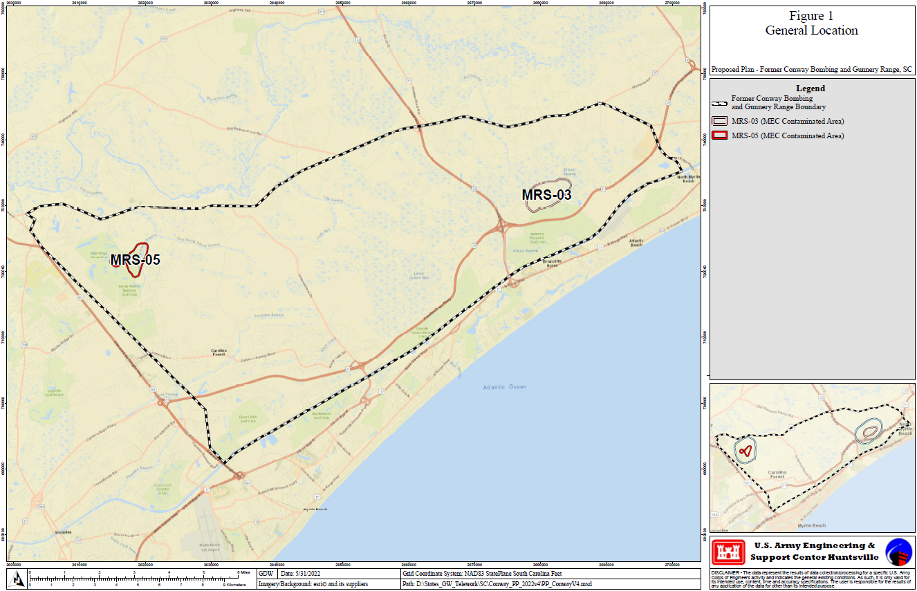
Figure 2 MRS-05 2015-2016 Remedial Investigation Intrusive Results
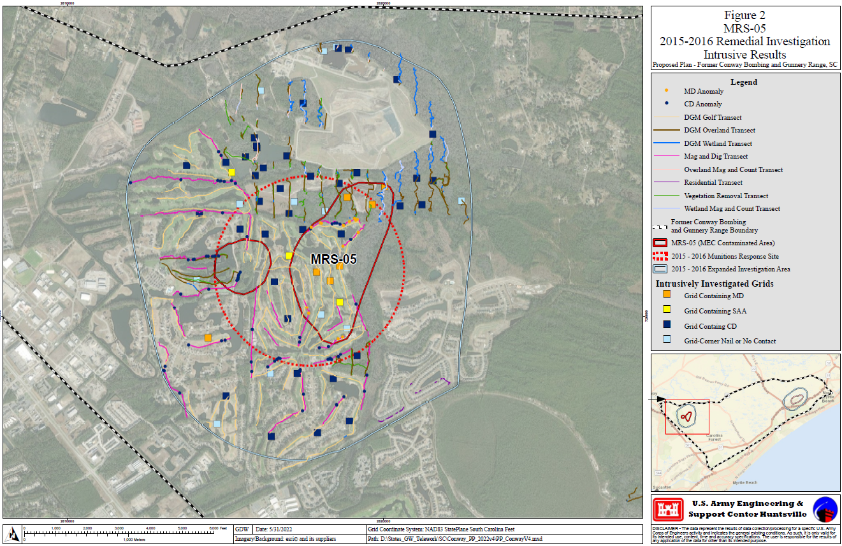
Figure 3 MRS-03 2015-2016 Remedial Investigation Intrusive Results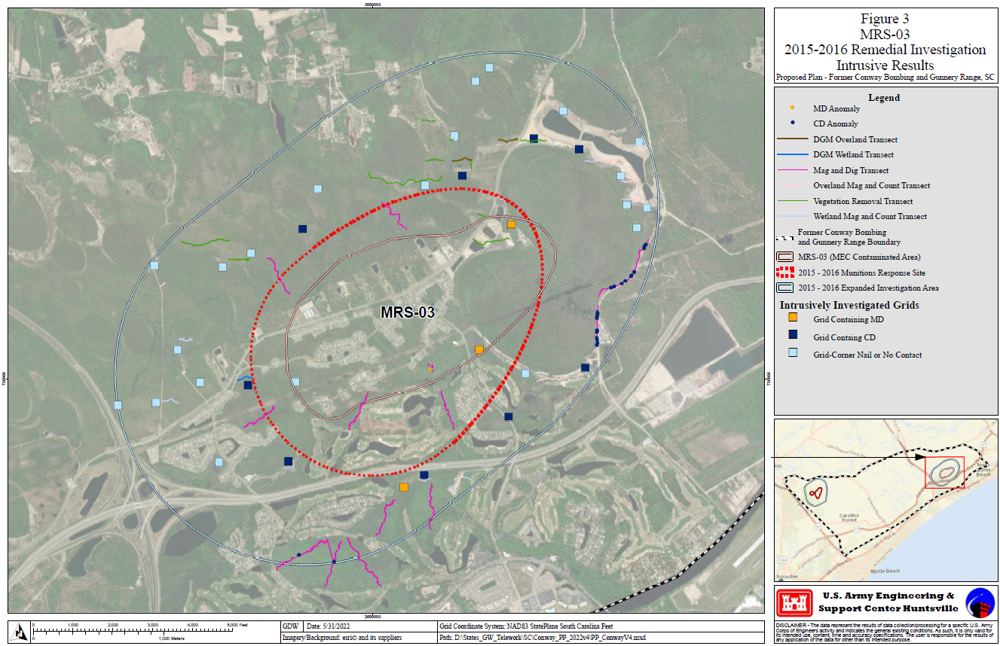

The terms used in this Proposed Plan that appear in bold type are defined in the Glossary at the back of this document.
A list of acronyms and abbreviations used in this Proposed Plan is presented following the Glossary at the back of this document.

